**Demand Builder:**

Demand Builder is a tool that automates the creation and alteration of demand files.

Demand files are used as inputs to the MARATHON model.

**Purpose:**

**Inputs:**

Demand records are built through merging three types of different files.

Each file type has a specific formatting that is required to correctly process a new file.

All file types are expected to be tab delimited text files. If the input file is given as an Excel file, it can be converted into text tab delimited by going to; file -> save-as -> browse -> in drop down menu, Text (Tab delimited).



For all file types, the header column names must match exactly to what is expected (exact formatting listed in respective sections). Additional columns can be present in the original file, however they will be ignored in the final output. If columns are improperly formatted, when running demand builder, the user will be notified of the file that is incorrectly formatted and column name that was expected. The expected column names will not necessarily match immediately given the initial input files. When the given file does not match exactly, the user needs to manually edit the column header names in the input files.

Finally, each file has a specific naming convention for the filename. The exact convention will be listed in each input file’s documentation section.

**Vignette Mapping File:**

The vignette mapping file describes the start and duration time for each vignette and each scenario.

This file initially comes from [somewhere].

Upon receiving this file, it needs to be formatted as a tab delimited text file and the indicator MAP_ needs to be put as the prefix of the filename.

The header column needs to contain the fields: *ForceCode*, *StartDay*, and *Duration*. Additional columns can be present and do not need to be remove. The ordering of these columns does not matter. The exact name of the columns needs to match (case sensitive).

**Vignette Consolidated File:**

The vignette consolidated file describes which SRCs are required in each vignette or scenario and the structure of each SRC.

This file initially comes from [somewhere].

Upon receiving this file, it needs to be formatted as a tab delimited text file and the indicator CONSOLIDATED_ needs to be put as the prefix of the filename.

The header column needs to contain the fields: *ForceCode*, *SRC*, *Title*, *Strength*, *Quantity*, and *Title10_32*. Additional columns can be present and do not need to be removed. The ordering of these columns does not matter. The exact name of the columns needs to match (case sensitive).

The Vignette Consolidated and Vignette Mapping file are joined on the ForceCode name. Sometimes the classification of the vignette unclassified (U)/ secrete (S) is given in front of the ForceCode; this is allowed and will not cause any issues. Apart from potentially having a classification in one file and not the other, the ForceCode values in Vignette Mapping file have to match exactly to what is in the Vignette Consolidated file. If there is a mismatch between the files, the all data for that Vignette or Scenario will not be in the final output file. Additionally, only events listed in the map are put into the final file. If a vignette is not present in the mapping file, but exist in the consolidated file, it will not be in the final demand record. Similarly, if a vignette is listed in the map but there is not corresponding data in the consolidated file, it will not appear in the final demand record.

**FORGE Files:**

Each scenario that has a demand will have its own FORGE file.

FORGE files come from [somewhere].

Upon receiving this file, it needs to be formatted as a tab delimited text file and the indicator FORGE_[FC] needs to be put as the prefix of the filename, where FC is the force code listed in the Vignette Mapping file. For example, the Forge file for scenario 3 should be called FORGE_SE-3.txt. If there is no Forge file for a scenario, then it should not be listed in the mapping file.

The FORGE files describe the quantity of SRCs needed over multiple periods of time. Typically, each time period is 8 days. FORGE files have two header columns to help describe the temporal data. The first header column contains the name of the operation’s phase. Each phase label should be directly above the column which indicates the time at which the phase starts. For example; FwdStation starts on time period 1, and should be directly above the column that says Day 0001 TP 1 in the second row.

The second row contains the second header. This row contains the descriptive fields of the SRCs required and the quantity required at a given time. In the original file, there is a cell for each time period (8 days). An empty cell indicates no demand at that time. A value in this cell indicates the quantity of this type of SRC at that time. The time period cells need to be formatted as Day xxxx TP x.

***In the original file, there is often a newline character *within* a cell. These need to be remove or else it will break and the scenario will not be included in the final demand record. To remove all new line characters within cells in Excel; go to find and replace (Ctrl+f), and replace all new lines (alt+010 on numpad) with “” (empty/nothing). Any non-special character whitespaces (not tab or newline) are allowed. ***

**Working Directory:**

Once all files are in the correct format, they should all be moved to a single folder. This folder will be referred to as the working directory within demand builder.

**Running Demand Builder**

When demand builder is ran, the user should see this screen:

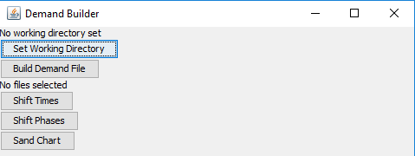

The first step is to set the working director by clicking the button. This will open a file select menu which the user should use to locate their working directory folder where they moved all of the formatted inputs to. The working directory can be changed at any point.

Once the working directory is set, the file select menu will close and the working directory will be displayed.

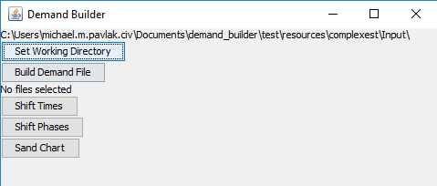

If there are no valid inputs in the folder indicated, a warning will be displayed telling the user no valid files could be found:

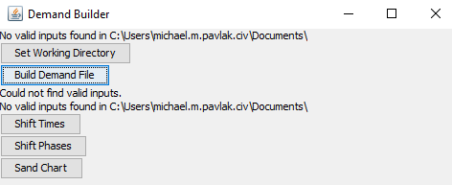

Once the working directory is set and valid inputs are found, the user can build the demand file by clicking the Build Demand File button. If there are no errors, the text area will display the files used in the creation of the demand file:

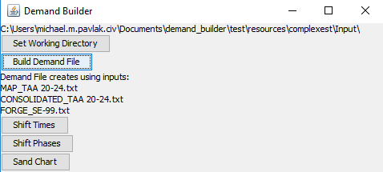

If there is an error with the expected formatting of the headers of each file, the file that is incorrectly formatted and the error throw will be displayed:

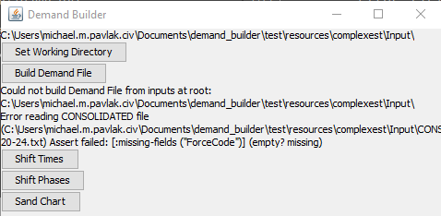

Once the errors have been fixed, the Build Demand File button can be pressed again to generate the file.

The new file will be created in the set working directory with the name [path]_DEMAND.txt, where path is the last subfolder in the working directory path.

In addition to creating new demand files, demand builder can change the newly created or already existing demand files in two different ways:

The first demand file adjustment that a user can specify is a systematic change in the start day of duration of a demand group. This can be done by clicking the Shift Times button while in a working directory that contains an existing demand file. A new window will appear;

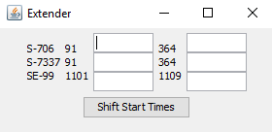

The first column indicates the demand group. The second column indicates the starting time. The final column indicates the ending time. The first text box will allow the user to adjust all start times by a given amount. The second text box will shift ending times by any given amount. Negative values are used to bring something forwards in time. Positive values shift something to a later point. Empty cells have no effect and will be ignored. Clicking the Shift Start Times button will update the existing demand file. If at any point the original file needs to be restored, it can be rebuilt by going back to the build demand step.

If phase timings within a scenario need to be updated, the user can do so through the phase shifter tool. Clicking the Shift Phases button will open a new window:

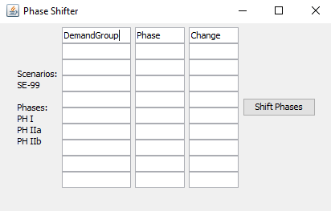

The DemandGroup column is the Scenario to be adjusted. The phase is the phase. The Change is the amount to shift (sign indicates direction). *Do not edit the first column. Changes to phases are done in order and are cascaded. For more specific information about how phase shifter works, see phase shifter documentation [here]. If there are any errors shifting the phases, the user will be notified with a new window with the detailed error message.

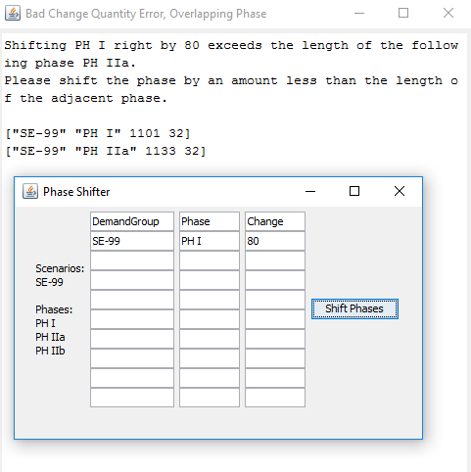

If no error message occur, the change will be made to the demand file and the phase shifter window will disappear.

The final functionality of Demand Builder is the ability to generate sand charts which indicate total personnel over time, grouped by demand group. This can be done by clicking the Sand Chart button.

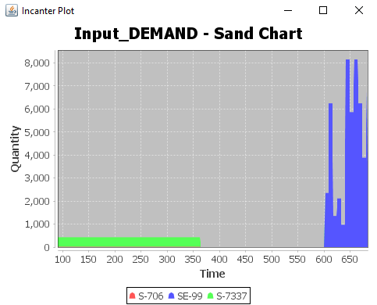

Charts are not automatically save. The image can be save by right clicking save-as on the plot window.